WMU Communication Datasheets
V 2018-03-25

Die WMU bietet, je nach Art der zu übermittelnden Daten, verschiedene Kommunikationswege an.  Bitte wählen Sie, je nach Art des Datenaustausch das passende Datenblatt zur Einrichtung der Kommunikation / Anbindung.  Für den Austausch kommerzieller Daten:  - EDI DataSheet  Für den Austausch von Konstruktionsdaten per Engdat:  - ENGDAT CAx DataSheet  Für den Austausch von Konstruktionsdaten oder beliebigen (Binär-) Daten:  - WebPortal DataSheet  Netzwerkanbindung z.B. für Fernzugriffe / Wartung / IT Leistung:  - VPN DataSheet (Site to Site)  Fernzugriff auf einzelne Dienste  - SSL Portal DataSheet |  | Depending on the kind of Data we need to exchange, WMU offers several ways of communication.  Please choose the datasheet that fits the needed kind of communication.  Exchange of commercial data:  - EDI DataSheet  Exchange of construction (CAD) data via ENGDAT:  - ENGDAT CAx DataSheet  Exchange of any kind of (unstructured or binary) data:  - WebPortal DataSheet  Network Connection e.g. remote connection or remote support:  - VPN DataSheet (Site to Site)  Remote Connection for single services  - SSL Portal DataSheet

EDI DataSheet / Connection Parameters

Global |  | WMU | Partner
 | Adress | Weser Metall Umformtechnik  Goettinger Landstr. 2-6  34346 Hann. Muenden
 | Mail | ddx@wmu.de
 | Contact Person | Name: Mark Pöpperl  Mail: mark.poepperl@wmu.de  Phone: +49 5541 9822 500  FAX: +49 5541 9822 61500 | Name:  Mail:  Phone:  FAX:
 | Online | Mo-Su / 0 – 24 h
 | Charset | ASCII / UTF8
 | Physical address (SSID/ SFID) | SSID: O0013001187WMU  SFID: O0013001187WMU
 | Parameters | Signed sending: No  Signed EERP: No  Compression: No  Restart: Yes
 | Partner Nr.
ISDN | Protocol | OFTP
 | Password
 | Network Service | ISDN
 | Network Number / Server (Prod) | +49 5541 955 799
TCP | Protocol | OFTP2
 | Password | by request via eMail / SMS / FAX
 | Certificate | by request via eMail
 | Network Service | oftp://ddx.wmu.de
 | Network Number / Server | 217.6.183.4
 | Network Port | 6619
 | Parameters | SecAuth: No  Signing: SHA1 with RSA  Encryption: AES

Supported Formats for EDI

Direction | Purpose | Preferred Format | Also Supported
outbound | Lieferschein / Delivery / ASN | VDA4913 | (EDIFACT) DESADV D96A, D97A, GLOBAL DESADV
outbound | Rechnung / INVOICE | eMail or Paper | GLOBAL INVOIC (VDA4938)
outbound | Lieferabruf / Delivery Forecast | VDA4905
inbound | Lieferabruf / Delivery Forecast | VDA4905 | DELFOR D96A, D97A, GLOBAL DELFOR (VDA4984)
inbound | Rechnung / Invoice | eMail or Paper | GLOBAL INVOIC (VDA4938)
inbound | Lieferschein / Delivery / ASN | VDA4913

The preferred VFN is “format.partner” e.g. ”VDA4905.NAME” for Delivery Forecasts or “VDA4913.NAME” for Delivery Notes.

ENGDAT CAx DataSheet / Connection Parameters

Global |  | WMU | Partner
 | Adress | Weser Metall Umformtechnik  Goettinger Landstr. 2-6  34346 Hann. Muenden
 | Mail | ddx@wmu.de
 | Contact Person | Name: Mark Pöpperl  Mail: mark.poepperl@wmu.de  Phone: +49 5541 9822 500  FAX: +49 5541 9822 61500
 | Online | Mo-Su / 0 – 24 h
 | Partner Nr.
ENGDAT | Protocol | OFTP2
 | Password | WMU968
 | Certificate | by request via eMail
 | Network Service | oftp://ddx.wmu.de
 | Network Number / Server | 217.6.183.4
 | Network Port | 3305
 | Parameters | SecAuth: No  Signing: SHA1 with RSA  Encryption: AES  Compression: No  Restart: Yes  Signed EERP: No
FTP | Protocol | FTP / SFTP
 | Network Service | Internet - TCP/IP
 | Network Number / Server | ddx.wmu.de
 | Network Port | 21
 | Username | by request via eMail
 | Password | by request via eMail

WMU may send Data via secure Download using Folderflex service.
You will receive an Email from “no_reply@wmu.de” or ddx@wmu.de containing a download link.

CAx Recipients

Name | Contact Info | Department | Adresscode
Poepperl, Mark  (Technical Contact) | Phone: +49 5541 9822 500  Fax: +49 5541 9822 61500  eMail: mark.poepperl@wmu.de | IT | ADMIN  (only for testing / admin tasks)
Tillmanns, Ottmar | Phone: +49 5541 9822 511  Fax: : +49 5541 9822 61511  eMail: ottmar.tillmanns@wmu.de | Design / Engineering | TO018

Requirements for exchange of CAx Data via OFTP / OFTP2

WMU will always send ENGDAT data.

ENGDAT File Transfer
If you’re able to send real ENGDAT (Abstract-file and data-files as package) the virtual filename, as defined in VDA 4951, must be used.
Virtual Filename after ENGDAT VDA 4951/1: ENGYYMMDDhhmmssXXTELmmmnnn

Non ENGDAT File Transfer
If you are not able send ENGDAT, please use the following virtual filename.
Virtual filename for pseudo ENGDAT: ENGYYMMDDhhmmssXXTEL001001

Remarks

YYMMDD = Date of Transmission (YY=Year, MM=Month, DD=Day)
hhmmss = time of transmission (hh=Hour, mm=Minute, ss=Second)
XXTEL = Adresscode of Recipient (a list of adresscodes is available on request, you may also contact the requested designer / recipient to ask for his / her adresscode)
For testing purposes you may use ADMIN
mmm = number of files in total (for pseudo ENGDAT use 001)
nnn = serial number of file (for pseudo ENGDAT use 001)
For pseudo ENGDAT, you must send each file with a unique virtual filename and it must end with 001001.

WebPortal DataSheet / Connection Parameters

Global |  | WMU | Partner
 | Adress | Weser Metall Umformtechnik  Goettinger Landstr. 2-6  34346 Hann. Muenden
 | Mail | ddx@wmu.de
 | Contact Person | Name: Mark Pöpperl  Mail: mark.poepperl@wmu.de  Phone: +49 5541 9822 500  FAX: +49 5541 9822 61500
 | Partner Nr.
Portal | Protocol | https
 | User | by request via eMail
 | Password | by request via eMail
 | Network Service | https://owncloud.wmu.de
 | Network Port | 443
 | Remarks | Best used with Firefox or Chrome Browser

Login screen:
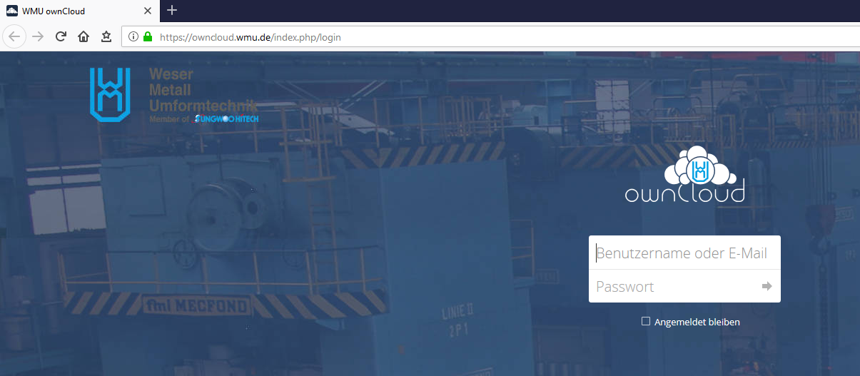
Root View:
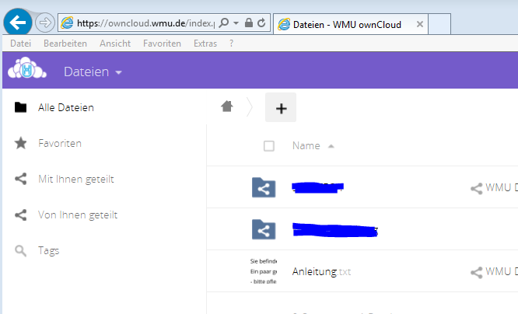

You will see (at least) one folder that has been shared with you.

Please upload data to this folder. You may also create subfolders within this folder.
Never upload data to the root view, as no one will be able to access this data.

Tipp:
Access you personal settings by clicking on your username in the upper right corner.
Change the language of the portal to your needs and activate eMail notification if new files get uploaded.

VPN DataSheet / Connection Parameters

Global |  | WMU | Partner
 | Adress | Weser Metall Umformtechnik  Goettinger Landstr. 2-6  34346 Hann. Muenden
 | Mail | ddx@wmu.de
 | Contact Person | Name: Mark Pöpperl  Mail: mark.poepperl@wmu.de  Phone: +49 5541 9822 500
 | Partner Nr.
GW | Gateway / Type of Connection | Checkpoint / Site to Site
 | IP | 217.6.183.2
 | Hostname | gw01.wmu.de
Settings | VPN Method | IPSec
 | IPSec Tunnel mode | Encapsulation Security Payload (ESP)
 | Authentication | Preshared Key (PSK)
 | Preshared Key | by request via eMail
 | IPSec Phase 1
 | Encryption Algorithm | AES256
 | Hash Algorithm | SHA1
 | Diffie-Hellman Group | 2
 | Lifetime (minutes) | 1440
 | IPSec Phase 2
 | Encryption Algorithm | AES256
 | Hash Algorithm | SHA1
 | Diffie-Hellman Group | 2
 | Perfect Forward Secrecy (PFS) | enabled
 | Lifetime (seconds) | 3600
Communication | Networks
 |  | 10.41.128.0 / 17
 |  | 10.41.8.0 / 24
 |  | 10.41.9.0 / 24
 | Hosts
 |  | 10.41.X.X (NNN)
 |  | 10.41.X.X (NNN)
 |  | 10.41.X.X (NNN)
 |  | 10.41.X.X (NNN)
 |  | 10.41.X.X (NNN)

SSL Portal DataSheet

Global |  | WMU | Partner
 | Adress | Weser Metall Umformtechnik  Goettinger Landstr. 2-6  34346 Hann. Muenden
 | Mail | ddx@wmu.de
 | Contact Person | Name: Mark Pöpperl  Mail: mark.poepperl@wmu.de  Phone: +49 5541 9822 500  FAX: +49 5541 9822 61500
 | Partner Nr.
Portal | Protocol | https
 | User | by request via eMail
 | Password | by request via eMail
 | Network Service | https://access.wmu.de
 | Network Port | 443
 | Remarks | Internet Explorer or Chrome Browser  NO support for Microsoft Edge

The SSL Portal may be used with username / password or RSA SecurID Token.

Login Screen:
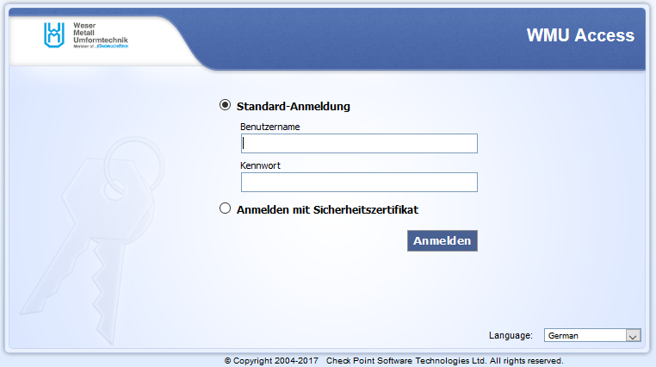

If you use a RSA SecurID Token the password is:
PIIN + Token Code

Start:

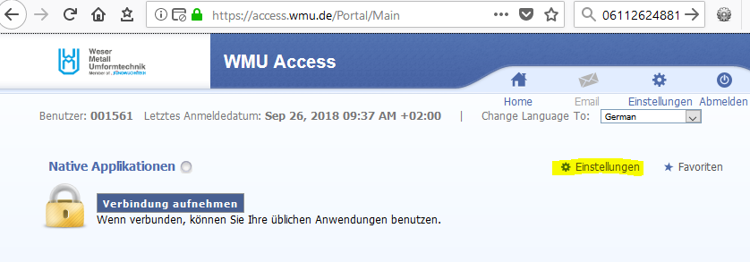

If you have acces to “Native Applications” please open the settings and activate “Network mode”

